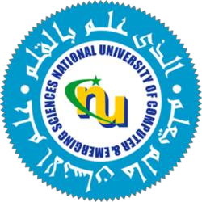

**Formal Report**

**Title:** Integrating International Best Practices Into Primary Education of Pakistan

**Course:** Technical and Business Writing

**Course Code:** SS-108

**Group Members:**

| **Afaq Khaliq** | **22l-6939** |
| --- | --- |
| **Hassan Javed** | **22l-6567** |
| **Shariq Munir** | **22l-6680** |
| **Abdul Ahad** | **22l-6769** |
| **Moiz Asif** | **22l-6720** |
| **Ali Zain** | **22l-6551** |

**Submitted To:** Mr Arsalan Rasheed

# UNDERTAKING

# 

This report is submitted as part of coursework for the course Technical and Business Writing (SS-108). The authors retain the rights to any future reproduction or reuse. The authors also affirm that this report is completed by their own efforts and has not been plagiarized from any source. If any plagiarism is found, the authors will bear sole responsibility. The authors of this report are in gratitude to the management of FAST NUCES and the course instructor for their continued cooperation, without which this report would not be made possible.

# ABSTRACT

Education system of Pakistan has suffered since its independence. Primary education, which is the foundation for learning, is subject to many challenges due to its heavy reliance on rote learning which limits critical thinking and creativity among students and thus hinders national development and progress. While the education system in countries like Finland and Singapore are successful because of better examination and teaching strategies.The Purpose of this study is to investigate the reasons for the existence of rote learning in the Pakistani education system by understanding the underlying problems, and study how it can be converted to a more meaningful learning method by integration of foreign education systems. To accomplish this task two online surveys were conducted, as we need to understand the problems students and teachers are facing in current education systems. Questions regarding teacher’s training, teaching methodologies and student’s learning experiences were asked. Additionally, a vast literature was also reviewed to further know the existing problems in the education system and understand how well known foreign education systems like Finland and Singapore tackle these problems.

Based on the analysis of the survey responses, it can be stated that factors such as outdated curricula, poor English literacy, and the lack of activity-based interactive learning methods are significant contributors to reinforcing rote learning. Furthermore, although most teachers have received formal training, they still lack the necessary infrastructure and tools to promote interactive learning. This study highlights the need for reformation in curriculum, one which emphasizes real world problem solving and is free from language restrictions, implementation of formative and summative assessments, and implementation of policies to increase equity among private and public sectors. While this study provides valuable insights into the topic there is still a need for future research.

# 

# TABLE OF CONTENTS

**UNDERTAKING 2**

**ABSTRACT 3**

**TABLE OF CONTENTS 4**

**LIST OF FIGURES 6**

**INTRODUCTION 8**

**LITERATURE REVIEW 10**

Problems in Pakistan 10

No Importance 10

Non-Uniformity in Education 11

Lack of qualified teachers 11

Parental involvement in children’s learning 11

Curriculum issues 12

Issues of textbooks 12

Outdated Examination System 12

To Conclude it’s linked to rote learning 13

Looking at International Models:Looking At Finland 13

The Philosophy of Finland 14

Decentralization 15

Equity 15

Qualified Teachers 15

Curriculum 16

Major Focus On Literacy 16

Facilities and Infrastructure 17

Parents involvement 17

Phenomenon-Based Learning 17

Accreditation and Certification examinations 18

To Conclude on Finland's success and avoid the problem of rote learning 18

Honorable Mention:Singapore 19

Student Assessment 19

Curriculum and its diversity 20

Teachers development 21

To conclude it links to rote learning 21

**METHODOLOGY 22**

Secondary sources: 22

Questionnaire Surveys (primary source): 22

Qualitative analysis: 22

Quantitative analysis: 23

**RESULTS AND ANALYSIS 24**

Teachers Survey And Analysis 24

Students Survey And Analysis 31

**CONCLUSION 38**

Recommendations: A step towards educational change in Pakistan 38

Decentralization 38

Equity 38

Teacher Qualification 39

Curriculum 39

Focus of Literacy 39

Facilities and Infrastructure 39

Parents' Involvement 39

Phenomenon-Based Learning 40

Better Examination System 40

**REFERENCES 41**

# 

# LIST OF FIGURES

Figure 1 24

Figure 2 24

Figure 3 25

Figure 4 25

Figure 5 26

Figure 6 26

Figure 7 27

Figure 8 28

Figure 928

Figure 1029

Figure 11 29

Figure 12 30

Figure 13 30

Figure 14 31

Figure 15 32

Figure 16 32

Figure 17 33

Figure 18 34

Figure 19 34

Figure 20 35

Figure 21 35

Figure 22 36

Figure 23 36

# 

# 

# INTRODUCTION

"'Education is not the learning of facts but the training of the mind to think'-Albert Einstein. Can Pakistan's education system embrace this philosophy?"

Rote learning can be defined as the process of repeating phrases until it becomes part of your long term memory.[10].Historically, rote learning has been used in many religions to preserve their scriptures [11], e,g Veda and Quran. Thus Rote learning is to some extent a very powerful technique especially for recalling important information. That’s why it is widely used by primary school teachers for making children learn basic mathematics like multiplication tables, or language vocabulary and spelling[15]. But when students use this technique only for passing examinations, it may not be a preferred learning strategy [12]. Although existing studies have shown that students having prior experience in rote learning tend to have better grades [13]. But obviously this is only possible in mostly south-Asian countries like Pakistan where the examination system heavily relies on memorization.

In Pakistan, one of the major problems in the education system is rote learning. Students prefer cramming and memorization over critical thinking, problem solving, and creativity, as a result students excel in their exams but fail to apply the knowledge on real-world scenarios. This limits their ability to compete with the globalized world.

Pakistan’s education system faces a lot of problems, including heavy dependence on English language, outdated curriculum , unqualified teachers ,etc. These factors compel students to resort to rote learning as a primary means of academic success.

Although a vast majority of individuals in the Pakistani education system recognize the issue of rote learning, there is still not enough research that has been done in this area to examine and eliminate the problem at its root cause. While studies have been conducted to some extent highlighting causes and drawbacks of this prevalent system of rote learning, focusing solely on one’s memorizing ability, not enough efforts have been made to address this issue by integrating foreign educational practices and consequently no long term measures have been proposed to achieve the purpose.

The purpose of this report is to identify the gaps in the Pakistani education system , particularly the lack of research related to rote learning and carry out extensive study to fulfill these gaps by offering solutions from foreign education systems to reshape and hence improve the standard and quality of education in Pakistan.

Main goal of this research is

1. To analyze the role of rote learning in the education system of Pakistan.
2. To examine how student’s academic and cognitive skills are affected by rote learning.

(3) To give a comparison with Foreign education systems..

(4) To propose methods and strategies that Pakistani schools can adopt to overcome rote learning.

For the better explanation of the particular problem, the work is divided into 5 chapters. The first chapter introduces the subject of research, its significance and objectives of this paper . The second section contains a survey of the relevant literature, more specifically, it reviews scholarly works on rote learning, its effectiveness, and its alternatives as practiced in abroad countries. The third section describes the qualitative research methodology applied in the study. The fourth chapter includes the results and discussion of the study presenting the results and analysis. Finally, the final chapter contains a brief description of the main findings and recommendations on how to alleviate the problem of excessive use of rote learning.

# 

# LITERATURE REVIEW

## Problems in Pakistan

Knowing about the problems in Pakistan’s education system and comparing it with global practices is essential for making changes in the country. Following independence on August 14, 1947, the majority of Pakistan's population, specifically 85%, lacked literacy skills, with women facing even harsher circumstances. Despite holding a conference to improve the education system and lower illiteracy rates, the outcomes were not achieved. Unfortunately, elementary education especially has not been given much attention within the education system. The education system in Pakistan has three phases: primary, secondary, and tertiary where primary schooling is least focused and funded. The state doesn’t recognize that reforming higher education depends on addressing primary education first. There are many reasons why the primary education system is battling with this; for instance, memorization versus developing analytical and problem-solving skills. To boost economic growth in the nation, it is essential to give the primary education system precedence, as the crucial development and learning stage happens in the early years of a student's life.

### No Importance

Since the beginning, Pakistan's education system has faced financial limitations, as the government has shown little interest in increasing budget allocation. Less than 2% of the nation's GDP is allocated to education funding [1]. Furthermore, Human Rights Watch has brought attention to substandard conditions in government and inexpensive private schools, an absence of oversight for private educational facilities, and prevalent corruption. The government has continuously put in a much lower amount of funding for education compared to what international standards suggest [2]. Additionally, substantial financial support, such as scholarships and grants, is given to universities and colleges, leaving the oversight of primary education to local districts, provinces, and federal authorities. Because of this lack of balance and limited resources, there are not enough public primary schools available, leading to many of them being unable to function properly. Corruption within public-sector school administration worsens the issue even more. While efforts are being made to enhance foreign-qualified Ph.D. programs in higher education through initiatives like the Higher Education Commission (HEC), there is a lack of serious measures being taken to guarantee quality primary education at the grassroots level. Due to the serious situation, numerous donors have come forward to support primary education via non-governmental organizations (NGOs). Nevertheless, these donor organizations frequently work independently, and their attempts to enhance educational programs and the standard of elementary education have not had a significant influence. As a result, their efforts have not greatly benefited the lives of underprivileged children [4].

### Non-Uniformity in Education

Due to structure and management issues, there are just 15,400 public primary schools in Pakistan with only 4,200 teachers in urban and rural regions. These schools are often severely underfunded and have only 2 or 3 classrooms, which is not enough to hold the growing population of students. Additionally, some schools don’t even provide basic amenities like washrooms and chairs [1]. Because of this poor infrastructure, teachers are not able to give students individual attention, a big bottleneck for good education. Poor children suffer especially because they don’t have a decent public education and cannot afford private education. On the primary level, private sector enrollments are said to make up nearly 40 percent of total students, filling the void left by public education. The lack of quality public primary schools and the state of most existing ones (deprivation of teachers and funds to pay for running costs) aggravate the issue [4]. One of the reasons behind Pakistan’s education disparity is the geography and cultural diversity of Pakistan. These differences have resulted in education viewpoints differing and the curriculum and methodologies not being agreed and normalized [3].

### Lack of qualified teachers

In Pakistan’s current regime, all it takes to be a primary school teacher is 10 years of education and an 11-month teacher-training certificate. The country has fewer than 300 teacher training and educational institutes, and close to 80 percent of these are state-owned and run. Other donors have also set up teacher training schemes with NGOs. These initiatives do not get teachers of the best quality employed in public schools [4]. Bad faculty training and professional development have left us with old methods of teaching and poorly developed curricula. This has prevented the development of thinking and problem-solving capacities in the students and they are poorly prepared for the future [3]. Not to mention a failure of communication and professionalism on the part of primary school teachers. They don’t pay any attention to the improvement of the education system and lack proper training centers to solve students’ academic and behavioral issues. Untrained teachers are ill-equipped to deal with unbalanced pupils, and they punish them with physical violence. As a result, children who graduate from primary schools lack the necessary communication and social skills [1]. This poor literacy and linguistic base makes it incredibly hard for students as they move on in school and pursue other degrees. These problems must be solved if we are to provide a solid educational foundation for the future.

### Parental involvement in children’s learning

Gonida and Vauras found that parental homework participation was positively correlated with child learning. A lack of parental support can lead to demotivation and hinder learning, whereas increased parental involvement benefits performance [5]. Illiterate parents often can’t help their children study or do their homework. And most parents can’t even supervise their children’s work because of socioeconomic conditions. During times of job stress, students miss class to help their parents. In turn, low parental engagement is directly detrimental to children’s education and performance [2].

### Curriculum issues

Pakistan splits its education into three main types: government, private, and Madrasa systems. Each type has its curriculum, but none meets today's world demands well. The education system faces problems because it lacks creativity in the curriculum and still uses old teaching methods. Primary education is very crucial, but it is often discarded and given less attention than higher education. Moreover, the current curriculum being taught is outdated. Memorizing facts is given more importance than developing thinking and problem-solving skills. Teachers try to finish the syllabus and get students ready for exams, which makes the curriculum's goals unclear. This results in a discrepancy in the curriculum goals and its usage[2]. On the other hand, teachers in developed countries focus more on shaping and improving study plans to keep them relevant. In Pakistan, children rely heavily on outdated information from textbooks. For a new and better education system to flourish in Pakistan, these issues must be addressed[1].

### Issues of textbooks

Teachers in Pakistan lack good textbooks and are faced with great teaching challenges. The school system that follows multimedia instruction only adds confusion to the teaching and learning environment. Furthermore, teachers are rarely adequately prepared to articulate and facilitate ideas from a wide range of textbooks. All these problems lead to poor teaching, and this discourages teachers and students. Thus, teachers are pressured to only concentrate on covering the syllabus in preparation for examinations instead of promoting learning about the content [1].

### Outdated Examination System

Pakistan's examination system has earned its place in the poorest category of assessment throughout the world as they're not, for one reason or the other, meeting both local and international standards or criteria set for examinations. Very traditional methods of assessment are utilized in schools, basically testing the memories of students rather than their performance, understanding, thinking, or problem-solving capabilities. Politics at the institutional level have often influenced examinations, giving way to opportunities for falsifications such as cheating and other forms of wrongdoing in the course of the examination. Inadequate quality of examination papers and grading procedures continues to confer further stains on the education system[1].

### To Conclude it’s linked to rote learning

Primary education is essential in determining the future of a country. When we look at the pasts of countries like Singapore and Malaysia, which gained independence later than Pakistan and were economically disadvantaged, we see that they have now advanced into developed nations. Their success in the global education arena is due to placing education as a top priority at a national level[2]. A frequently neglected concern in literature is the literacy level of students and their comprehension of language. This issue arises from a combination of factors including outdated curricula, low-quality textbooks, ineffective examination processes, a shortage of competent teachers able to effectively teach, limited parental engagement, and inadequate government funding for improving primary education. This directs the students towards mere rote memorization, which severely impairs creative and critical approach capabilities. However, this educational gap is evident through differentiating public from private schools. Wealthier parents have the facility to send their children to expensive private schools, recognized for training creativity and innovation, while children with fewer resources have to attend public schools. The disparity in education standards for public and private schools is something traditionally not found in most developed and developing countries, highlighting the continuous relevance that plays a role in equality and excellence in the education system of Pakistan [2]. Various studies that outline the challenges presented by Pakistan's institutionalized education are suggesting reforms, with most of them strongly advocating for increased funding for elementary education. However, they tend to neglect the aspect of how it should be done, which scrambles down most of their specific tactics and practical steps toward effecting change in institutions. For example, although there have been discussions on the differences between the education systems of Finland and Pakistan, there is limited advice on incorporating Finland's successful practices. This study seeks to close the divide by investigating practical remedies. Before exploring those answers, we will analyze some effective global education strategies.

## Looking at International Models:Looking At Finland

Finland is often regarded as one of the best in the world when it comes to education systems. The Finnish government has, therefore, designed a flexible educational model around the idea of "less teaching, more learning." This approach has produced distinguished alumni like Linus Torvalds, developer of the Linux kernel, a free operating system. Almost 30% of the Finnish higher-education system students are concentrated in sciences: forestry, material science, environmental science, neural networks, low-temperature physics, brain research, biotechnology, and genetics. Finland's concentration on this area has drawn for itself the title of pioneering scientific studies. Every part of Finland's educational system plays a role in its achievements. In the PISA tests of 2000 and 2003, Finnish students exceeded students from other European countries, surprising educators and policymakers. Finnish students have continuously obtained high rankings in the fields of science, reading, and mathematics. The Finnish educational structure is incredibly seamless. On average, Finnish students learn about 36.1 hours per week, the least of any PISA 2015 country, while the OECD average is 44.0 hours. While they can hardly compete in terms of learning time, Finnish students are excelling, and thus constitute one of the most effective systems globally. Some of the highest, like Singapore, do well academically; but these students spend so much more time learning than their Finnish counterparts, which also emphasizes Finland's very unique efficiency[2,6,8]. A total of nine years, constituting six years of primary schooling and three years of lower-secondary schooling, form the education system in Finland. This evaluation will mainly focus on these six years of primary schooling as the real foundation of Finland's great performance in education[8].

### The Philosophy of Finland

Exercise of choice is afforded a high place in the Finnish educational system; no standard, no rankings among individuals or schools, and no competitive rivalry among regions until the high school years. The primary goal is to make high-quality education available to all citizens of Finland, moving beyond simply acquiring trivial skills, talents, and personalities. Some of the key aspects of the Finnish education system include free schooling, free school lunches, and specialized education for those with special needs, all rooted in an ethos of inclusivity. The Finnish philosophy of education tends to identify and therefore appreciate the diverse capacities of human beings. It guarantees that students who struggle in certain subjects are not forgotten. To help, additional instructors are frequently in classrooms to aid students who are having difficulty with specific lessons, however, all students stay in the same classroom regardless of their abilities. Finland adopts a lifelong learning approach: free education is made available from preschool through university[8]. The system aims to develop seven fundamental competencies:

C1: Reflection and acquisition of learning skills

C2: Cultural knowledge, interaction, and communication

C3: Self-care, daily living skills, and security

C4: Multiple literacies

C5: Functional use of digital devices

C6: Career management and entrepreneurship

C7: Engagement and accountability for a sustainable future[7]

Rather than aiming for uniformity, Finland fosters changeability and variety, developed around a broad knowledge palette that covers all spheres of individual development and education[6]. It's built on trust and professionalism and hence avoids the sort of competitive behavior that often accompanies GERM. Finland sees education more holistically, “Educate not only the head but also heart and hands”[2].

### Decentralization

There's special mention of checks and balances within the Finnish system of democracy, which help to foster trust. Depending on the local authorities in Finland, schools have a varying degree of autonomy. Though several services are provided by the school, it must adhere to the requirements established by law. The Finnish educational system rests on the foundation of trust. This principle removes the need for inspecting schools as this trust is bestowed upon the system and Finnish society as a whole towards their teachers: their professionalism and competence[6].

### Equity

In Finland, private schools do not exist; basic education is seen as a fundamental entitlement for all children. This shows the solid dedication of both the Finnish population and the government to ensuring top-notch education for every child[2]. A key aspect of the Finnish education system is that it is provided without charge at every level, including university. From the earliest educational stage to higher education, there are no charges for tuition. Furthermore, educational resources, books, medical care, and transportation are offered at no cost to students residing a great distance from the school during their early schooling years. Most writers on the subject consider the belief that there must be a fair distribution of resources such that those in need are given the necessary assistance to be a cornerstone of the Finnish system of education. It is manifested by the full absorption of the strong backing provided by special needs education in the overall Finnish school system[6]. The Programme for International Student Assessment (PISA) has consistently underscored the strength of Finland's commitment to equity in education. Surprisingly similar educational opportunities are made available for the disadvantaged and advantaged school children, thus maintaining equal learning opportunities for children at the mercy of the market or geography. Another interesting feature of the system is access to preschool for every child. The Finnish government guarantees preschooling opportunities beginning from the age of six, as by law required. The state also has a role in improving the quality of education, including ensuring free meals, textbooks, and the absence of fees for formal education[2].

### Qualified Teachers

In Finland, teaching is a highly respected profession with stringent requirements to ensure the competence of educators. Teachers at the 9-year compulsory basic education level must hold a Master’s degree in Education, while preschool and kindergarten teachers require a Bachelor’s degree. This high standard is upheld through a rigorous three-stage selection process involving a competency exam, interviews, problem-solving simulations, and a comprehensive evaluation of the candidate’s skills and qualifications. Teacher education balances theory and practice, requiring approximately 180 credits for a Bachelor’s degree and 120 for a Master’s degree[8]. These teachers spend a mere 10-15% of their study time at clinical training schools, obtaining genuine hands-on exposure in classrooms. Research and training, conducted under the surveillance of the government for continuous professional development seeking to address weaknesses and improve instruction abilities, serve as vital for this group of educators. Finnish teachers are highly competent in the subject matter and pedagogy, employing a mixture of methodologies, relatable examples, and active student involvement as the cornerstone of their practice. The principle behind Finnish education is equity whereby children with special needs are given extra care to eliminate disparities of performance between low achievers and high achievers. The profession enjoys significant societal respect and trust, making it one of the most sought-after careers. The emphasis on quality, combined with Finland’s culture of trust and autonomy, allows teachers to use creative and effective approaches in their classrooms. These factors contribute to the success of Finnish education, ensuring inclusive and high-quality learning for all students.[6,8]

### Curriculum

A student is entitled to receive educational materials and activities along with a comfortable environment for learning from early childhood to tertiary education stages in Finland. The fundamental aim of the pre-primary curriculum is to facilitate children's readiness for basic education through learning assisted by play. Basic education begins at the age of seven in Finland. Private schools don't exist in Finland, and all kinds of educational establishments follow a uniform national curriculum containing directives. This uniform national curriculum now lays down guide provisions with latitude for local educational administration authority, schools themselves, and, last but not least, parents to enrich their essence in shaping the curriculum and goals for the individual children. The Finnish education system adopts a unified curriculum model for the whole duration of primary education, which lasts nine years. Pupils are generally taught for an average of six years by the same teacher. This is to ensure continuity in learning and to enable a teacher to focus on developing the student's abilities and honing their talents.[8]

### Major Focus On Literacy

A distinct feature of the Finnish educational program is its significant focus on becoming proficient in language and literature, which also includes learning foreign languages. Finnish education places a strong emphasis on literacy skills, providing students with an edge in assessments such as PISA which places a significant emphasis on literacy. Moreover, Finland's robust reading culture plays a major role in the academic achievements of students. Reading with purpose is seen as a key element for success in every academic field. Finland's wide library network is evidence of the population's regular practice of borrowing and reading books.[6]

### Facilities and Infrastructure

Finland's system has shown that, unlike in other places, education must not be determined by the quality of school buildings. The Finnish model allows students to make choices about their learning space within classroom areas, not just in the ordinary confines of classroom walls but sometimes outside them. Where students feel bored or tired, teachers suggest some breathing space or even a game for refreshment. Although most lessons occur in classrooms where students sit while the teacher lectures, flexibility is allowed to provide for various settings to cater to students' needs. The Finnish government mandates guidance and counseling services, particularly directed at students with mental health issues or other special needs. Mental health and well-being provisions ensure that every student including those with special needs gets the support essential for success. Unlike some countries where students with special needs are set apart, in Finland such students receive a complete education within normal schools. Moreover, Indonesian school pupils do not normally receive free nutritious lunches thought to help with their cognitive development and promotion of general health.[8]

### Parents involvement

From a Finnish perspective, parental involvement forms a very important foundation. In Finland's educational processes, parents or guardians are mostly involved in raising their children, and overall, they are quite satisfied with their child's school. In addition, parenting works toward assisting the child's development in the educational system. Their belief and positive attitude influence the positive values towards schools in their children. The "100 Finland" initiative includes the largest-ever parent-teacher conference, in which 100 projects spread Finnish educational innovations. There are 25 pilots of these projects currently taking place in schools across the country. One such initiative, "100 Global," will collect innovative ideas from around the world while another will feature discussions with 100 education experts across all continents. Finland became the world's pioneering country as the first to conduct the education system without traditional school textbooks or courses.[2]

### Phenomenon-Based Learning

The educational program of Finland reveals characteristics that differ from the GERM approach. Finland's Education System puts an accent on holistic learning rather than testing and competition. Their philosophy is based primarily on nurturing whole persons, i.e., the heart and hands, not merely the intellect. Finland has devised Phenomenon-Based Learning, which differs from the conventional structure of the curriculum; while subjects are taught separately within this kind of instruction, phenomenon-based learning attempts to teach students through events embedded in real-world contexts while at the same time bouncing from the well-worn curriculum. A method providing intellectual and manual assistance in developing 21st-century skills such as creativity, critical thinking, innovation, and effective communication has also been initiated. Children learn more interactively and digitally, engaging in ways that encourage collaboration and problem-solving [2]. Every basic school in Finland for students between the ages of seven and sixteen must include a module of at least one extended period for multi-disciplinary learning based on phenomena. The approach nurtures collaborative practices within the classroom, with students benefiting from the presence of multiple teachers during project-based studies.[7]

### Accreditation and Certification examinations

Indeed, at this crossroad, Finland students abandon rankings and numbers during compulsory basic education; that is the national curriculum intent is to promote understanding and application. Rankings of students and schools as well as grades awarded for particular background knowledge have all been abolished. Basic education is all about the building up of every character and child. The Finnish government does not practice the retention of grades. This system was initiated to make equality and mental prosperity supreme priorities of the child. Structured assessments, report cards, and continuous homework are not part of the Finnish educational system. Schooling achievements are observed by way of matriculation examinations conducted before arriving in higher education. Setting learning goals depends on each student with guidance from their parents while stressing the gradual process and making real meaning. The Finnish learning experience emphasizes practical problem-solving, especially in the case of the sciences, to enable an authentic understanding of the world. Thus, there is no state accreditation of Finnish schools; they are, rather, evaluated by their users-encompassing mainly the students and their parents. What is most critical in the evaluation process is the extent to which an institution produces children imbued with basic attributes like integrity, intelligence, and well-balancedness. The government guides school-oriented policies, systems certification, and eventual accreditation of quality schools with continuous support to ensure that other institutions come in line with the standards that are expected.[8]

### To Conclude on Finland's success and avoid the problem of rote learning

All the elements listed above play a part in creating an educational setting in which students prioritize comprehension over rote memorization. The quality of teachers and the focus on literacy are two of the most crucial factors. Students who can effectively read, write, and communicate do not have to depend on memorizing information through repetition. The process of teaching involves more than mere rote learning for pupils. It also requires an analytical and conceptual ability on the part of the learner in reasoning and understanding the definitions. Also to be reckoned with are the ways by which teachers impart lessons. Finland places a high premium on its teaching profession, and teachers dedicate a personal level of attention to each student. The support is delivered especially for low-performing children. Teachers are trained in the management of dynamics in the classroom and the presentation of content in ways that guarantee comprehension on the part of students. Furthermore, parental participation is crucial for the academic achievement of students. Parents supervise the teaching to help their children carry out the required responsibilities and offer the necessary support. Finally, the Finnish education system proposes that cooperation is a superb idea while competition is not. Unimportant assignments, projects, and classroom activities make up student assessments instead of high-stakes testing, so learning occurs and is less encumbered by exam pressure.

## Honorable Mention:Singapore

Singapore is one of the top countries in terms of PISA scores and has one of the best education systems globally. However, when compared to Finland, it falls short in some areas. Since its inception, Singapore has undergone numerous education reforms. Internationally benchmarking its education system, Singapore has participated in the triennial PISA survey since 2009 and the quadrennial TIMSS since 1995. As the Deputy Director-General of Education (Curriculum), Mr. Sng Chern Wei explained in 2019, "PISA results remain a useful international reference for MOE(Ministry Of Education) as we develop our education policies and programs." These serve as invaluable fodder to the MOE in the development of strengths and areas of improvement within the Singapore education system.[9]

### Student Assessment

Reduction of School-Based Assessments: The mid-year examinations for the Primary 3, 5, and Secondary 3 levels have been removed because these are transition years where the academic content becomes more demanding. This revision is meant to help reduce the level of stress among students and provide them with extra time to adjust to new academic expectations. Primary school students in the first two grades will no longer take formal examinations but complete small tests and quizzes as an indication of learning progress.

Changes in Assessment Regimes and Reporting: There should be no more than one weighted assessment per subject per term in all schools for all levels. Students' class or cohort position in exams will no longer be reported in the Holistic Development Profile, formerly known as the Report Book. Instead of ranking, students would receive even more feedback from teachers in written and verbal ways.

PSLE changes: The Primary School Leaving Examination will move away from numeric scores to broad achievement bands that are criterion-referenced and standards-based in 2021. This moves away from over-emphasis of examination grades and the unhealthy competition amongst young children.

School-based assessments are like elsewhere in much of the world, heavily dependent on paper-and-pencil tests, projects, and reports. However, there are performance-based components for some subjects such as listening and speaking skills in languages, practical tasks for science, and creative portfolios or mini-performances in art, music, Design, and Technology.[9]

### Curriculum and its diversity

Key milestones in the development process involved: i) scanning for global trends, issues, and educational policies; ii) consultations from classroom teachers and school leaders concerning the relevancy and challenges of content and teaching methods; and iii) convening an expert consultation committee comprising senior MOE curriculum staff, teachers, master teachers, representatives of the local exam boards, polytechnics, industry, and the National Institute of Education (NIE). Self-governing and autonomous schools in Singapore, therefore, have to integrate interdisciplinary curricula that would allow students to build their intellectual, sporting, and aesthetical lives in keeping with the values and beliefs of the school. Schools can also have flexibility in modifying the sequence of subjects covered and even selecting or omitting certain contents to better meet the needs of their students. Teacher professionalism is highly regarded in Singapore, and innovation in instructional strategies and assessment receives significant attention. Teachers are encouraged to try many different teaching strategies, for which efforts are recognized through sharing opportunities, local conferences, and award ceremonies. More importantly, learning is made more engaging and challenging with various alternative assessment platforms: performance tasks and mini-projects. This provides opportunities for peers and teachers to give feedback. Though science and mathematics are considered vital subjects in the development of STEM careers, non-academic subjects are just as important in developing character and citizenship qualities in students. The competencies that are required for life beyond the school setting, including values and social-emotional competencies, are given prominence in the curriculum. From this perspective, therefore, no subject is more important than another in school. The main curriculum has focused on: (a) subject-based learning in languages, sciences, and the arts; (b) knowledge and skills through project work; and (c) character development through CCE and co-curricular activities. The GEP offers an enriched curriculum for academically gifted students from Primary 4 to Primary 6. These range from applied learning in robotics, electronics, and sports sciences, among others, in which students learn to link abstract learning to real-life problem-solving. Further reinforcing these competencies and dispositions is the Learning for Life Programme, which helps students contribute to society. Schools also provide computer laboratories to enhance the technical skills of students, such as design software, Excel, and word processing.[9]

### Teachers development

Teachers in Singapore are among the youngest in the world and reportedly as hardworking as their counterparts in other developed countries. Teachers in state-funded schools should have a teaching qualification acquired from the National Institute of Education. A university graduate who chose teaching as a profession would be taken for 16 months of training at the NIE with 14 weeks of field experience or teaching practice. Singaporean teachers take into consideration six key areas of practice: assessment literacy, inquiry-based learning, differentiated instruction, support for students with special educational needs, e-pedagogy, and character and citizenship education. The MOE works in close collaboration with NIE to provide PD for both pre-service and in-service teachers. These PD programs are organized at four levels of teaching practice: emergent, proficient, accomplished, and leading. The international reviews on the quality of teaching and teachers in Singapore have been very positive.[9]

### To conclude it links to rote learning

The Singaporean curriculum, though not faultless, has achieved a certain amount of diversity in providing different opportunities for young students to experiment with the arts and music subjects. This kind of diversity encourages novel perspectives and develops the students holistically. Furthermore, Singapore secures much attention to teacher development: international reviews underline its methodology of teaching. The country has also cut down assessments to just one per term, intending to reduce stress among primary school pupils and make them focus more on productive learning rather than striving to pass exams alone. This change will no doubt create a holistic and enjoyable learning environment.

# 

# 

# 

# 

# 

# 

# 

# 

# 

# 

# 

# 

# 

# METHODOLOGY

## **Secondary sources:**

* Comparative Analysis: A comprehensive review of educational systems in countries known for their effective primary education systems, such as Finland, New zealand and Singapore.
* Identification of Best Practices: Analysis of successful scholastic techniques, curriculum frameworks, teacher training programs, and assessment strategies implemented in these countries.

## Questionnaire Surveys (primary source):

To gather primary data, an online questionnaire was designed using Google Forms. This tool allowed for efficient data collection and analysis. The questionnaire was distributed digitally to a diverse sample of teachers and students, ensuring a wide reach and maximizing participation. The questionnaire included a variety of question types, including multiple-choice to capture a comprehensive understanding of the challenges in primary education in Pakistan.

* **Teacher Questionnaire:** A structured questionnaire designed to gather data on teachers' perceptions of:
  + Teaching methodologies employed
  + Curriculum effectiveness
  + Teacher training adequacy
  + Student engagement levels
  + Perceived causes of rote learning
* **Student Questionnaire:** A simplified questionnaire tailored to primary school students to assess their:
  + Learning experiences
  + Perceptions of teaching methods
  + Attitudes towards learning

## Qualitative analysis:

Qualitative analysis was conducted by examining research articles as primary sources. These articles focused on the challenges faced by Pakistan's education system, particularly in comparison to countries like Finland and Singapore. By analyzing case studies of successful education systems, we were able to identify key factors contributing to their effectiveness, such as strong teacher training, innovative curriculum design, and a focus on student-centered learning. This comparative analysis provided valuable insights into potential areas for improvement in Pakistan's primary education system.

## Quantitative analysis:

Quantitative analysis was conducted on the data collected from the online questionnaire survey. The data was analyzed using statistical software to identify trends and patterns. Key findings were derived from the analysis of the following:

* **Teacher perceptions:** Data on teachers' attitudes towards teaching methodologies, curriculum effectiveness, and the impact of teacher training.
* **Student experiences:** Data on students' perceptions of learning environments, teaching methods, and the use of technology.

By analyzing the quantitative data, we were able to identify key areas of concern and potential solutions to improve the quality of primary education in Pakistan.

# 

# RESULTS AND ANALYSIS

## Teachers Survey And Analysis

**Figure 1**

**Forms response chart. Question title: Have you received formal teacher training?
. Number of responses: 29 responses.**

The vast majority of respondents (86.2%) had formal teacher training, according to this pie chart. Even though this shows a promising trend, the fact that rote learning is so common in Pakistan raises the possibility that the caliber and efficacy of these training courses need to be re-evaluated. Instead of only emphasizing information delivery and memorization, it is crucial to make sure that teacher training programs give educators the pedagogical tools they need to encourage critical thinking, problem-solving, and active learning.

**Figure 2**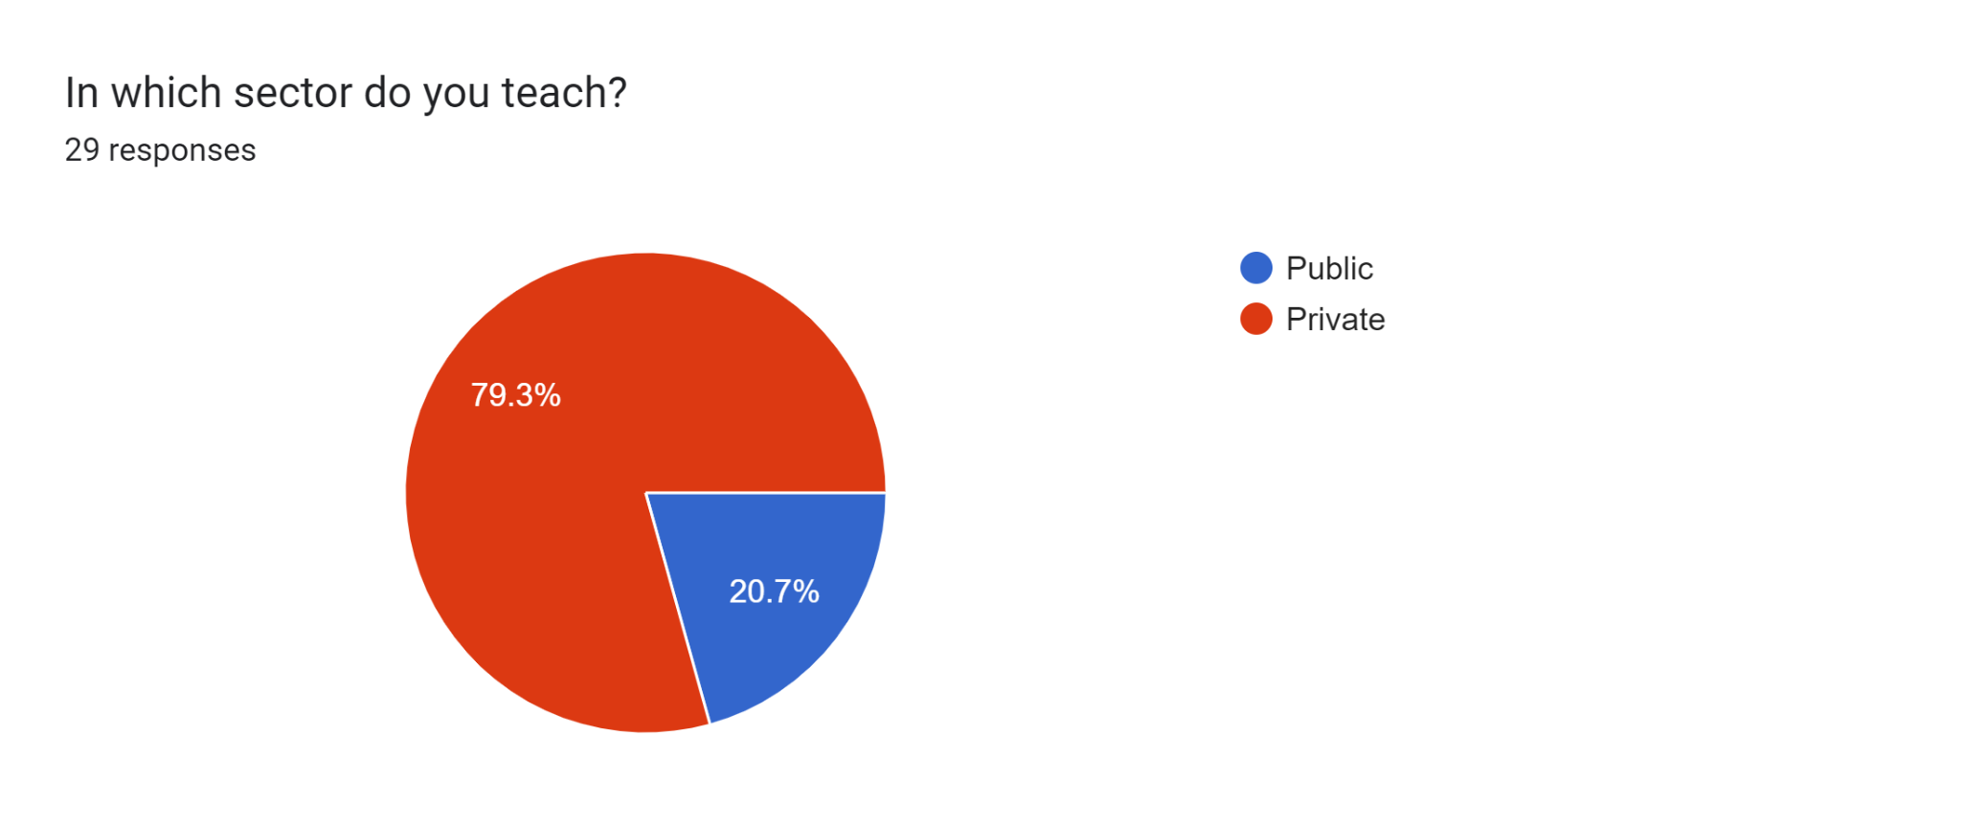

According to this pie chart, 79.3% of respondents work as private sector teachers, whilst just 20.7% work as public sector teachers. Higher pay, better working circumstances, and greater chances for professional growth in the private sector are some of the reasons behind this trend. These elements could influence the quality of education in public sector institutions by encouraging talented teachers to attend private schools rather than public ones.

**Figure 3**

**Forms response chart. Question title: Do you conduct group activities among students in your class?
. Number of responses: 29 responses.**

According to this pie chart, just 58.6% of respondents engage in group activities on a regular basis, 37.9% do so occasionally, and 13.8% do so infrequently or never. This implies that group projects, which can encourage critical thinking and active learning, are not frequently utilized in Pakistani classrooms. Since students aren't encouraged to interact meaningfully with the subject, the absence of active learning chances may lead to rote learning..

**Figure 4**

**Forms response chart. Question title: Do you give students breaks during lessons to maintain their focus?
. Number of responses: 29 responses.**

According to the preceding figure, 55.2% of respondents give their students periodic breaks to help them stay focused, compared to 37.9% who do so frequently. This implies that even though some educators understand the value of breaks, a sizable percentage do not always use them. In the end, this could impede effective learning and possibly reinforce rote learning habits by making students tired and less engaged.

**Figure 5**

Forms response chart. Question title: How competitive are the students in your class?
. Number of responses: 29 responses.

According to the data, 41.4% of respondents said they thought their pupils were highly competitive. Because of their intense rivalry, students may prioritize getting good scores over studying the material, which could lead to a stressful learning environment. This may result in an emphasis on rote learning and memory at the expense of critical thinking and problem-solving abilities.

**Figure 6**

Forms response chart. Question title: Do you encourage your students to be competitive?
. Number of responses: 29 responses.

According to this pie chart, 75.9% of respondents said they always or occasionally encourage their students to be competitive. This implies that Pakistani schools often have a competitive environment. Although competition might spur students to put in more effort, it can also cause them to prioritize performance and grades over comprehension and learning.

**Figure 7**

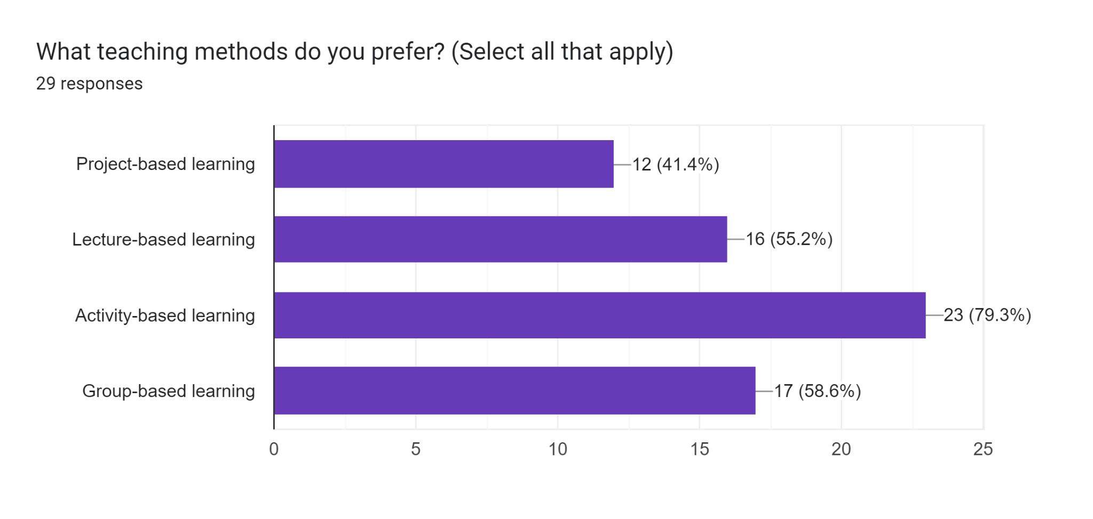

The most popular teaching modalities selected by respondents are activity-based learning and group-based learning, followed by lecture-based learning and project-based learning, as this bar chart illustrates. This implies that active learning strategies that involve pupils and promote involvement are typically preferred by Pakistani educators. Nonetheless, lecture-based learning—which may be less engaging—is still widely used.

**Figure 8**

Forms response chart. Question title: Do you believe the curriculum you teach is outdated?
. Number of responses: 29 responses.

According to the chart, a sizable percentage of educators believe that the curriculum is out of date, which can impede students' ability to think critically and solve problems.

**Figure 9**

Forms response chart. Question title: Do you believe exams are necessary at the primary level?
. Number of responses: 29 responses.

The respondents' differing views on the value of primary school exams are depicted in the pie chart. Exams are required for assessment, either on a regular or sporadic basis, according to 44.8% of respondents, while 44.8% disagree. In order to prevent unnecessary stress on young learners, this research emphasizes the necessity of a balanced approach to assessment that supports both formative and summative assessment techniques.

**Figure 10**

Forms response chart. Question title: How well do your students understand the English language used in the curriculum?
. Number of responses: 29 responses.

According to the figure, a sizable percentage of responders (34.5%) think their pupils comprehend the English language utilized in the curriculum. Nonetheless, 20.7% think their comprehension is fair, and 31% think it is above average. This implies that even while some students are proficient in English, a sizable portion may find the language of teaching difficult, which could impair their ability to learn and comprehend.

**Figure 11**

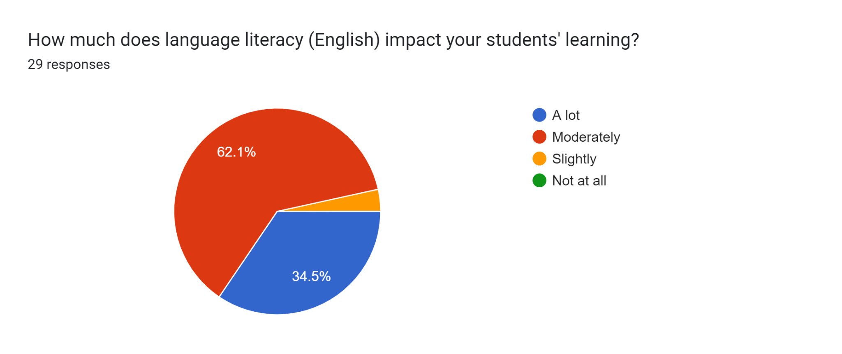

According to the figure, the majority of respondents (62.1%) think that their pupils' learning is significantly impacted by language literacy, specifically English. This implies that success in Pakistani academia depends on having a solid grasp of English.This emphasizes how crucial it is to give students high-quality English language training and resources so they may participate completely in the program and acquire the language proficiency required for successful learning.

**Figure 12**

Forms response chart. Question title: Do you give individual attention to students in your class?
. Number of responses: 29 responses.

According to the graphic, most teachers give each pupil individualized attention, indicating that they recognize how important it is. But a sizable fraction hardly ever or never do, which can impede the involvement and advancement of students.

**Figure 13**

Forms response chart. Question title: Do you believe Pakistan's primary education system needs major reforms?
. Number of responses: 29 responses.

According to the data, a sizable majority of respondents (72.4%) think that significant reforms are necessary in Pakistan's primary education system. This reflects a general belief that substantial reforms are necessary since the current system is not fulfilling the demands of the students. This research emphasizes how urgently substantial reforms are needed to address the problems with Pakistan's primary education system, especially those related to infrastructure, curriculum development, and teacher preparation.

## Students Survey And Analysis

**Figure 14**

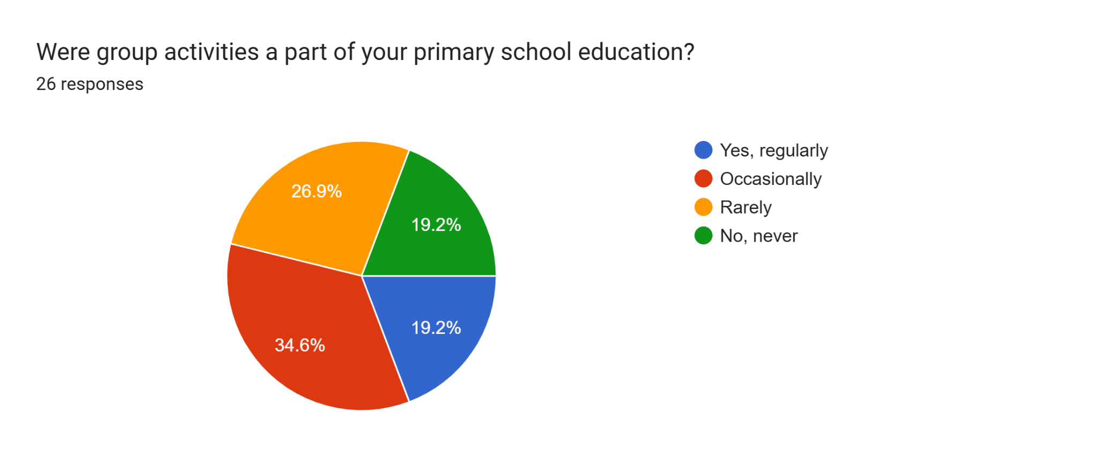

There is no doubt that group activities can actually do a lot in fighting rote learning. They can help students to:

* There is creative thinking and critical thinking.
* Learn from each other
* It helps to develop communication and/or collaboration skills

The outcomes of the pie chart imply the fact that group activities are not included as part of primary school curriculum in Pakistan. It is likely to add to the common vice of rote learning in the country owing to the fact that…

**Figure 15**

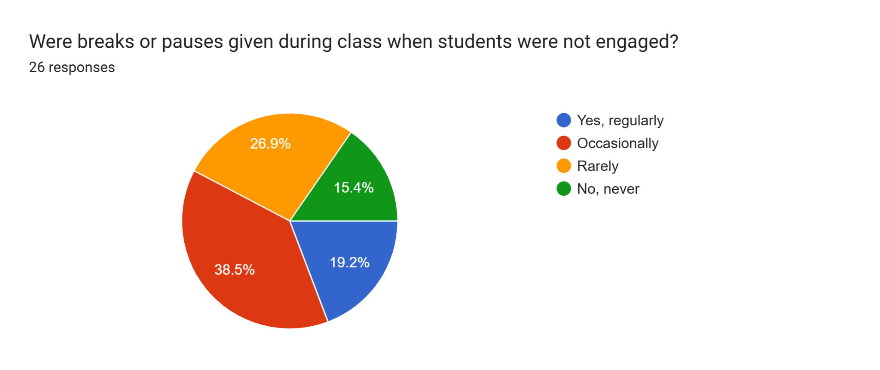

As the data of the pie chart indicates there are limitations in the School/College to providing breaks or pauses whenever students are not in class. This probably adds up to the mass production mindset in learning that already pervades the educational system within Pakistan. Preliminary or interruptions are useful to mitigate the problem of rote learning. They can assist students in organising knowledge, paying attention and even self-considering.

**Figure 16**

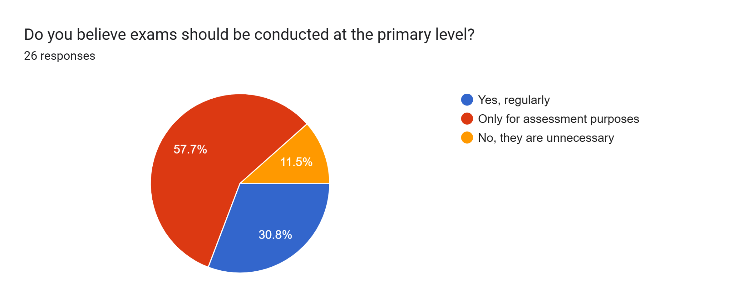

To some extent, the data is divided in terms of opinions pointed towards the requirement of exams at the primary levels. While a noteworthy margin (57.7%) continue to have confidence in them as assessment tools, many (30.8%) consider them redundant in this level of education.Traditional exams main focus is to test the memory retention capability of students, thus forcing learners to cram in order to answer.

A large proportion of (30.8 %) of learners were of the view that traditional exams were not relevant in this level of education since they only provided

**Figure 17**

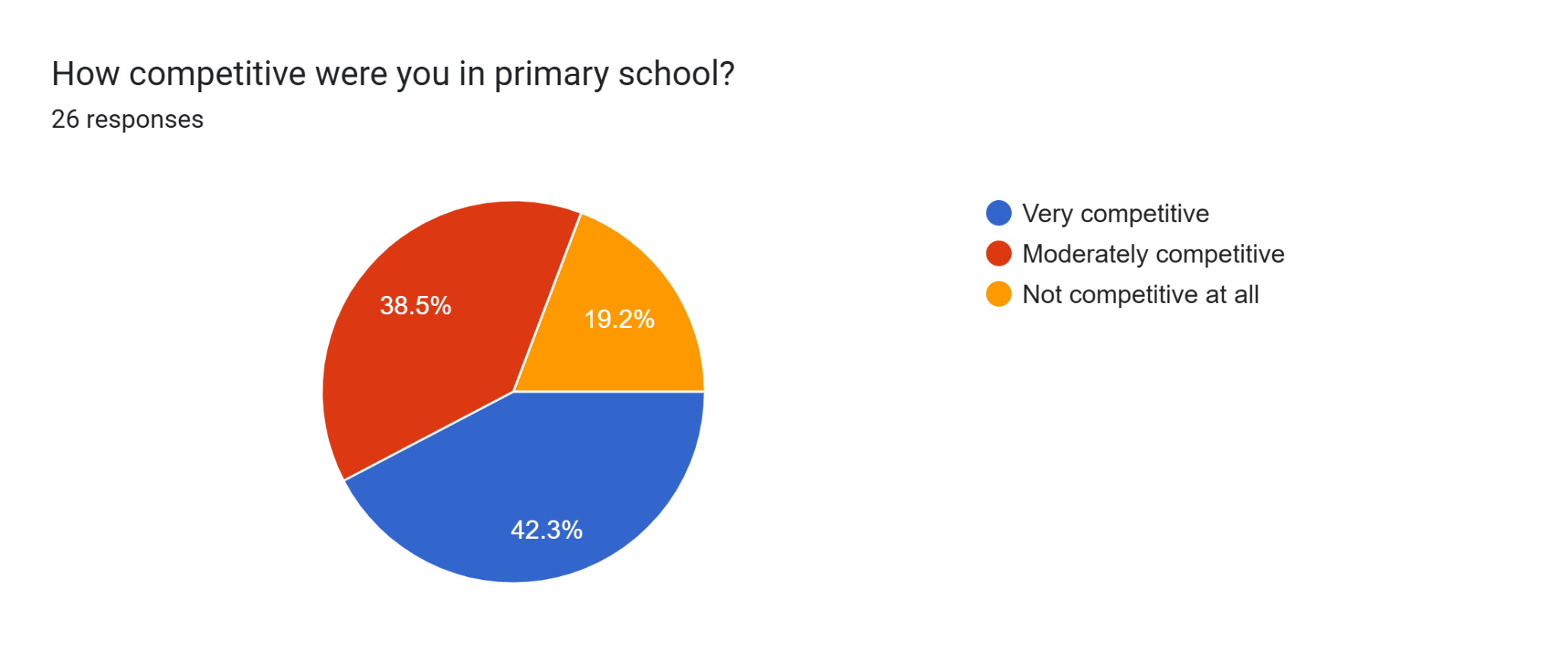

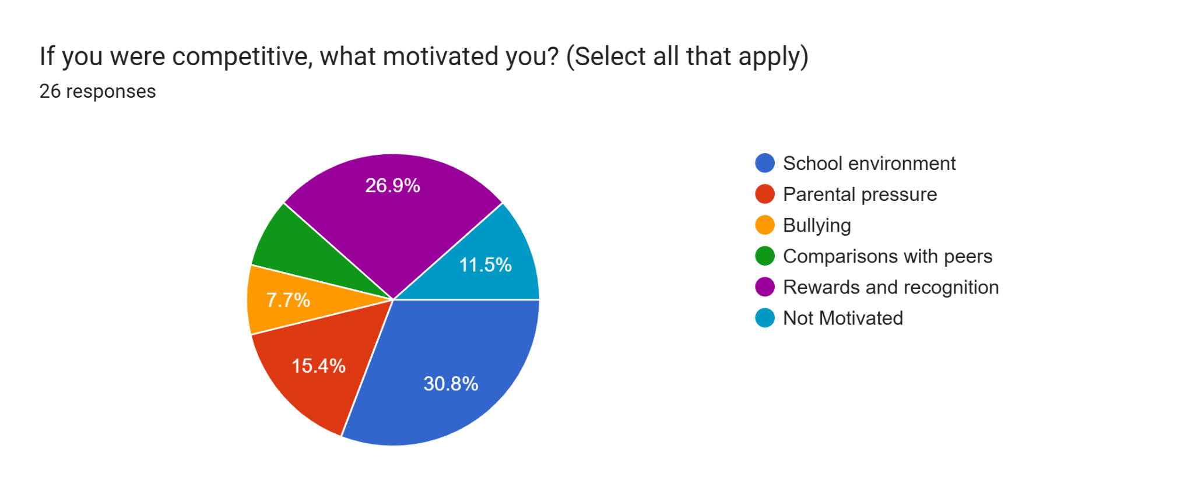

The first of the above charts shows that there was a high percentage of students who reported being very competitive in their primary school. As much as this competitiveness might stem from the school culture and having to meet expectations, it puts students on a path to learning by rote. High competitiveness is characteristic of the school environment and when it gets established students may tend to focus their efforts on achieving satisfactory academic success and demonstrate it through high marks, high rates even if they do not really understand the material.

**Figure 18**

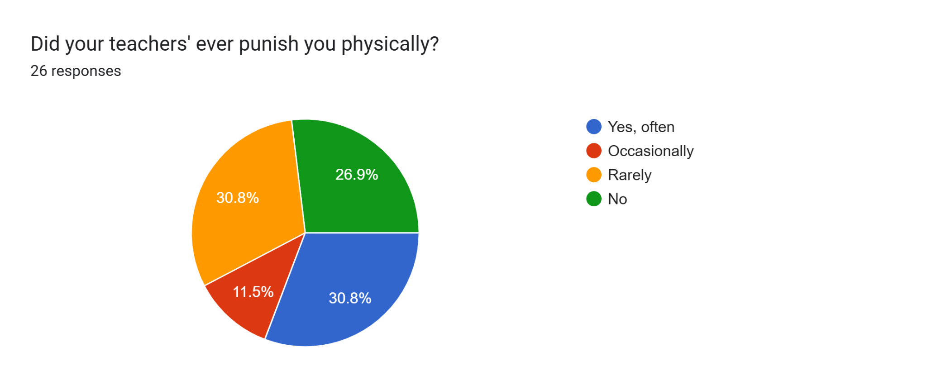

30.8 % of respondents often received physical punishment from their teachers. Spanking, which is widely used in many schools around the world or in Pakistan specifically stops child learning and development. Punishment may take precedence over learning, since the latter can result in the former. This leaves students with no option but to cram thus leading to poor understanding of the courses learnt.

**Figure 19**

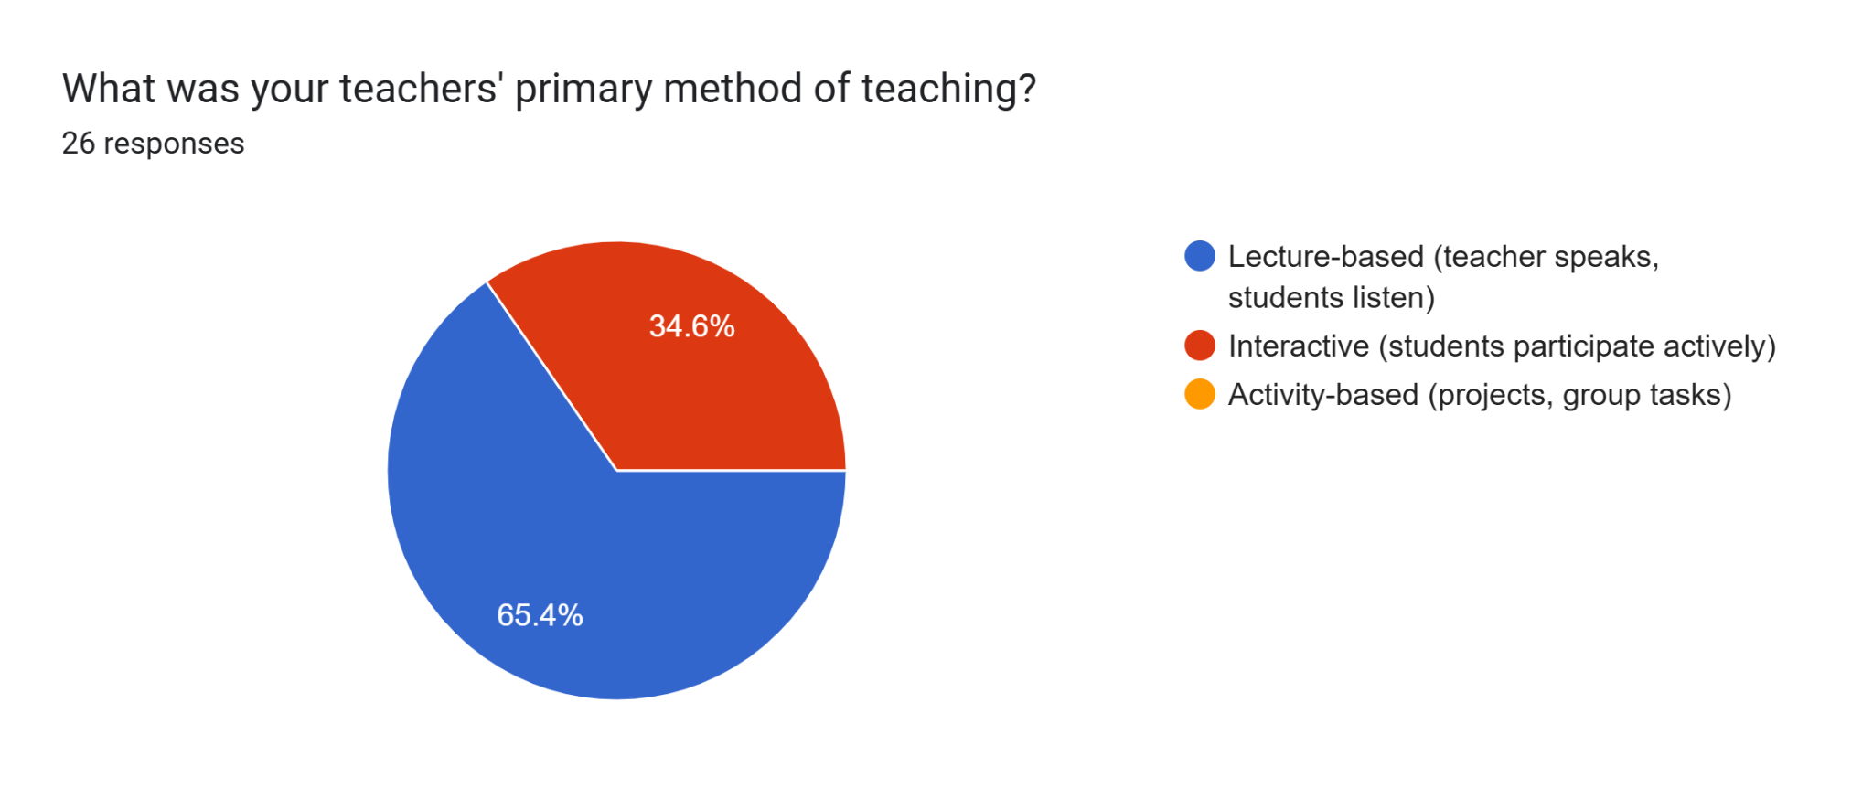

65.4 % of the respondents said that they use a lecture-based approach. As a result, lectures make excellent information delivery tools, but their use in a classroom can lead to rote learning if students do not engage in active learning. In cases where students are mere receptors of these pieces of information they may end up merely reproducing these pieces of information on the subject without having an inkling of what the particular subject is all about.

**Figure 20**

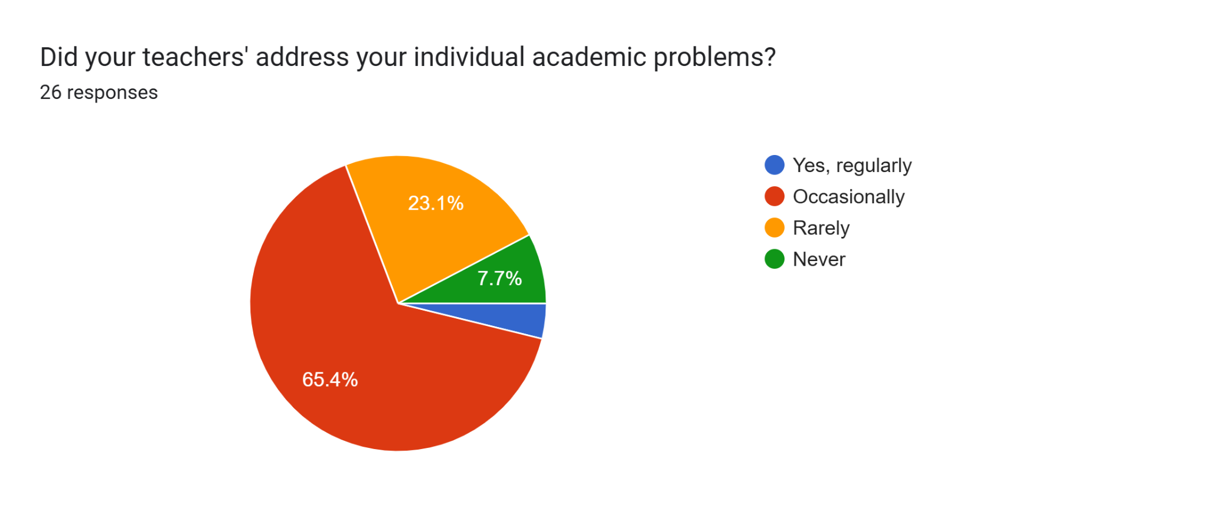

65.4% of respondents indicated that their teachers occasionally addressed their individual academic problems. Without individualized support, students may resort to memorization techniques as a way to cope with academic challenges. This can hinder their ability to think critically and solve problems.

**Figure 21**

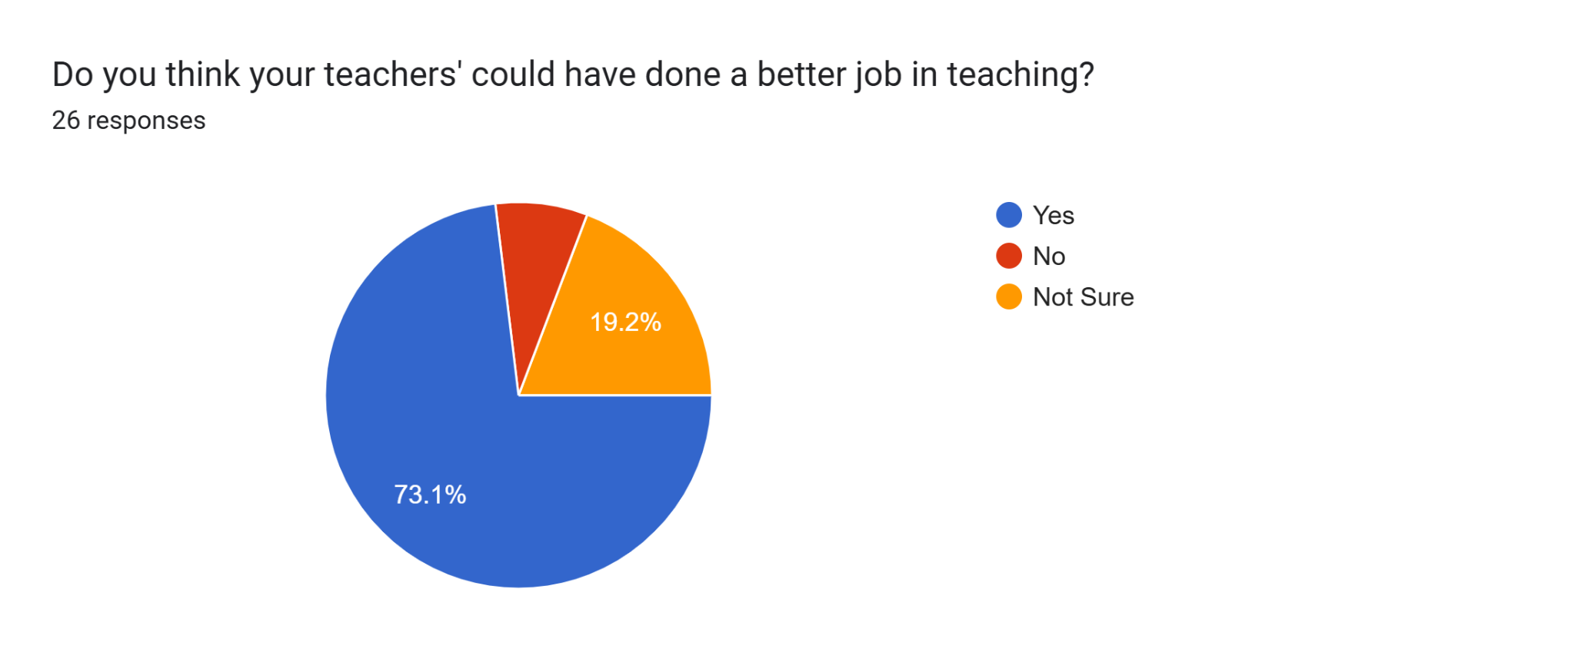

73.1% of respondents opine that it was possible for their teachers to do a better job in teaching. Majority of the respondents complained of their teachers' poor performance. This means that there could be systematic factors that make up the education system which inhibits learning of students.

**Figure 22**

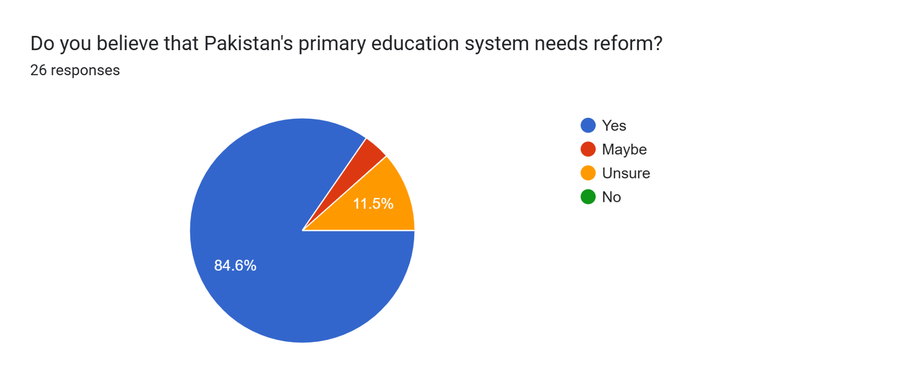

84.6% of the respondents said that there is a problem with the primary education system in Pakistan. This begs the question on why there exists such an overwhelming need to change the existing system as most people yearn for reform.

**Figure 23**

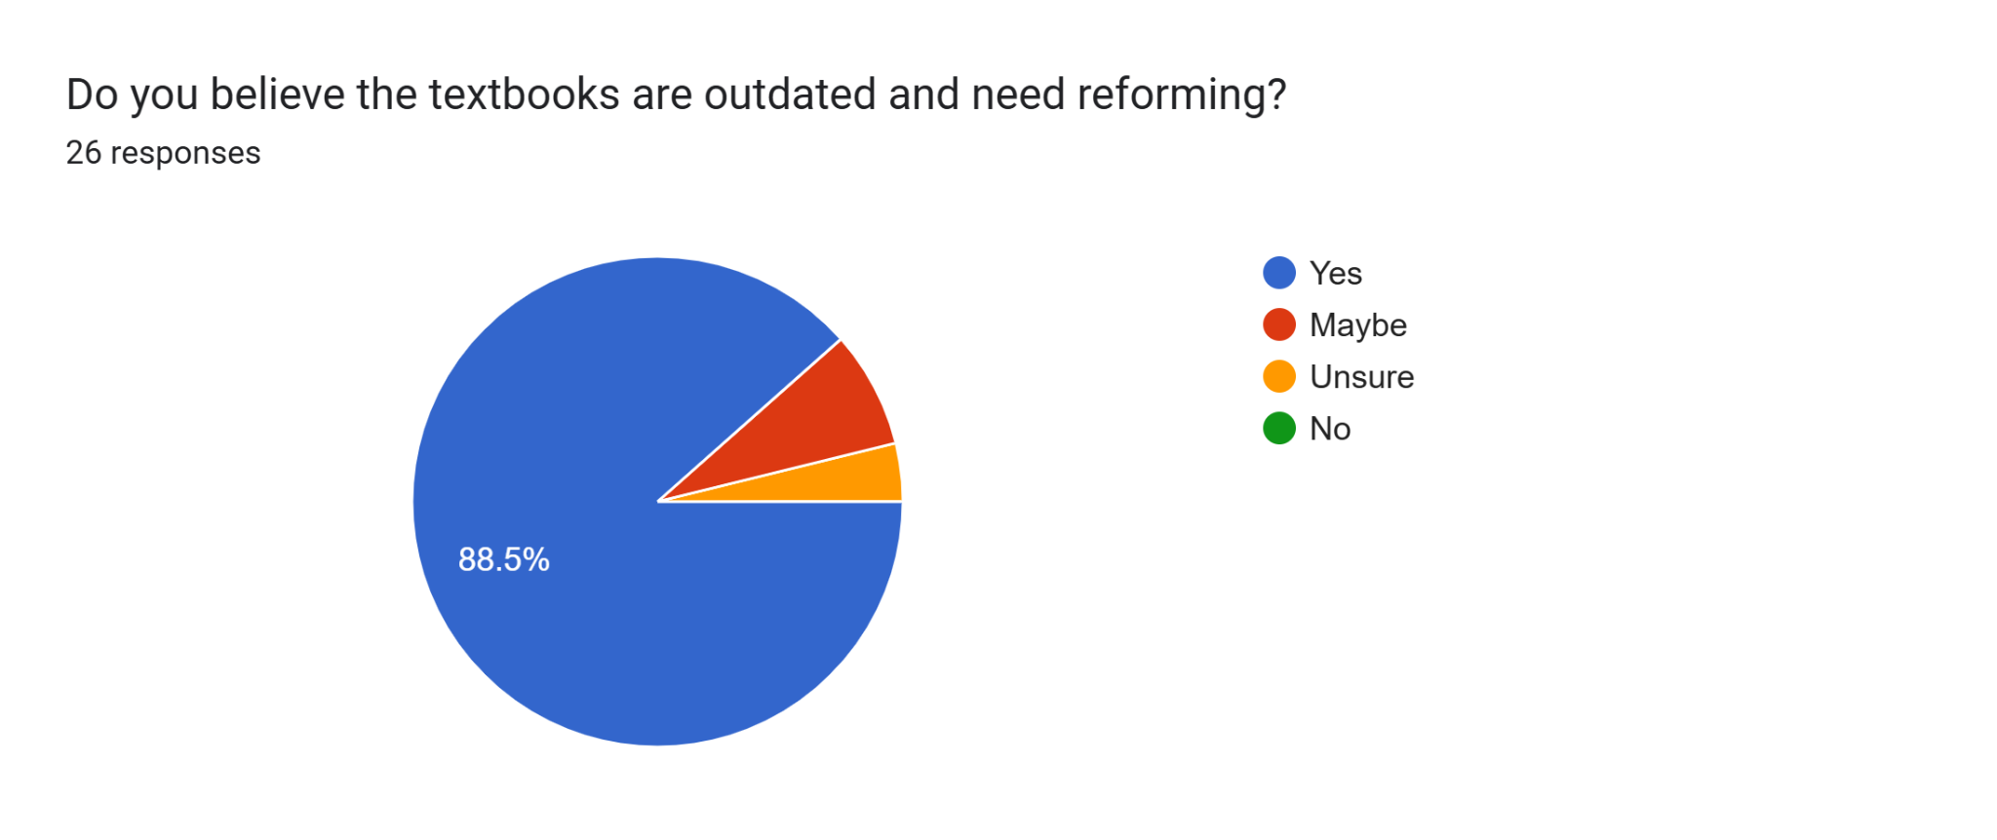

According to results 88.5% of respondents opined that textbooks used in Pakistan are bad and need change. The textbooks reform has never been so overwhelmingly demanded as what has been indicated in this study and this indicates that there is a major problem in the context of education in Pakistan. Course books even if they are out of date tend to promote mechanical and rote learning approaches to problem solving and critical thinking.

# 

# 

# 

# 

# 

# 

# 

# 

# 

# 

# 

# 

# 

# 

# 

# 

# 

# 

# 

# CONCLUSION

The analysis of Pakistan's primary education system, with a focus on the detrimental impacts of rote learning, mentions the importance of systemic reforms to address the critical challenges faced by the nation's students. The excessive dependence on memorization as the primary mode of learning has suppressed creativity, critical thinking, and problem-solving abilities, creating a gap between academic performance and practical application of knowledge. This gap not only affects student’s ability to compete on a global stage but also limits their contribution to Pakistan's socio-economic development.

There are multiple root causes for these challenges which include an outdated curriculum, inadequate teacher training, lack of infrastructure, and insufficient focus on student engagement collectively creating an environment that prioritizes exam performance over meaningful learning. Furthermore, imbalance in educational quality and equality between public and private schools leaves needy students at a disadvantage. The lack of government investment in primary education has continued this cycle of inefficiency and inequity.

However, the comparative analysis of successful education systems such as Finland and Singapore provides valuable insights into potential solutions. Finland's focus on equity, personalized learning, and teacher professionalism demonstrates the power of an comprehensive and flexible education system. Similarly, Singapore's focus on innovation, reduced assessment pressure, and holistic curriculum development offers a pathway for creating a more balanced and engaging learning environment.

## Recommendations: A step towards educational change in Pakistan

It is therefore important that to achieve meaningful reform of Pakistan’s primary education system a systemic reform strategy is required. Key areas of focus should include:

### Decentralization

* **Empowering Local Communities:** Devolution of power to local people helps in coming up with proper-fit solutions to education problems.
* **Flexible Curriculum:** Let schools adjust the curriculum in order to meet the needs of their locality and environment.

### Equity

* **Equal Access:** Provide equal opportunities for students by improving childhood education in order to exclude nobody on the basis of their social status or gender.
* **Inclusive Education:** Give school education to children who have disabilities.

### Teacher Qualification

* **Rigorous Teacher Training:** Introduce strict training of teachers so as to enhance the quality of education.
* **Continuous Professional Development:** Offer training for the purpose of personal and professional continued development to improve the skills of teachers.
* **Competitive Salaries and Incentives:** Give reasonable wages and salary in order to attract excellent educators.

### Curriculum

* **Focus on Critical Thinking:** Move from superficial learning to problem solving, critical thinking skills and creativity among others.
* **Real-World Relevance:** Draw up a programme relevant to student’s everyday experiences and their lives and future experiences ahead of them.
* **Multilingual Education**: Support fulfillment of multilingual education to improve the learners’ thinking abilities and embrace cultural diversity.

### Focus of Literacy

* **Holistic Literacy:** Promoting both basic formal literacy, particularly reading and writing, as well as literacy that needs the use of technology in accomplishing the aforementioned literacy.
* **Critical Literacy:** Help the students to look for meaning and critically assess information.

### Facilities and Infrastructure

* **Adequate Classrooms:** Make sure that students can find space and classrooms whenever there is need, depending on the number of schools.
* **Basic Amenities:** Piped water and sanitation facilities and electricity should be availed to the students.
* **Modern Technology:** Provide schools with modern technology equipment like computers, and lab apparatus to aid learning.

### Parents' Involvement

* **Parent-Teacher Meeting:** Parent-Teacher Meetings should be encouraged in a bid to assure support between parents and teachers.
* **Parent Education:** As for parents, extend knowledge about children’s development and positive parenting behaviors.

### Phenomenon-Based Learning

* **Real-World Context:** Teach concepts in relation to phenomenon in the natural environment in order to make learning more interesting.
* **Inquiry-Based Learning:** To motivate students to be active inquisitors, to search and to explore on their own.

### Better Examination System

* **Formative Assessment:** However, formative assessments must be employed in order to offer frequent feedback and enhance student learning.
* **Summative Assessment:** Summative assessments should be employed for students’ evaluation and also for making instructional decisions.
* **Reduce Exam Stress:** Reduce the amount of stress by fewer high stakes tests and incorporate more low stakes tests.

If tackled, these areas will help improve the quality of primary education, and in return build empowered future generations of Pakistan.

# REFERENCES

| **[1]** | Ahmad, M. Raul, A. Rashid, S. ur Rehman, and M. Salam, "Analysis of the problems of the primary education system in Pakistan: Critical review of literature," vol. 4, no. 2, Mar. 2013, ISSN: 2223-9944 |
| --- | --- |
| **[2]** | M. Farooq, Q. W. Ahmed, and G. Rehman, "A critical study of Finnish education system in contrast to education system in Pakistan: Equity, quality and parental involvement," *Journal of Educational Research and Professional Development*, vol. 1, no. 1, Jan–June 2021, Fatima Jinnah Women University, Rawalpindi. |
| **[3]** | M. Akhtar, Z. Andleeb, and S. Akhtar, "Problems of education system in Pakistan: A critical analysis and solution," *Pakistan Social Sciences Review*, vol. 8, no. 2, pp. [insert page numbers], Apr.–Jun. 2024, P-ISSN: 2664-0422, O-ISSN: 2664-0430. |
| **[4]** | M. A. Ashraf and H. I. Ismat, "Education and development of Pakistan: A study of current situation of education and literacy in Pakistan," *US-China Education Review B*, vol. 6, no. 11, pp. 647–654, Nov. 2016, doi: 10.17265/2161-6248/2016.11.003 |
| **[5]** | Gonida, E. N., & Vauras, M. (2014). The role of parents in children’s school life: student motivation and socio-emotional functioning. British Journal of Educational Psychology, 84, 349–351. <https://doi.org/10.1111/bjep.12048>. |
| **[6]** | U. Ustun and A. Eryilmaz, "Analysis of Finnish education system to question the reasons behind Finnish success in PISA," *Studies in Educational Research and Development*, vol. 2, no. 2, pp. 93–114, 2018. |

| **[7]** | M. Søby, "Finnish education system," *Nordic Journal of Digital Literacy*, vol. 10, no. 2, pp. 64–68, 2015, ISSN: 1891-943X. |
| --- | --- |

| **[8]** | A. M. Sari, Abdulah, W. Maladerita, A. Ananda, Rusdinal, and N. Gistituati, "State Finland education system and Finland education best practice," *International Journal of Humanities Education and Social Sciences (IJHESS)*, vol. 1, no. 6, pp. 960–969, Jun. 2022, E-ISSN: 2808-1765 |
| --- | --- |

| **[9]** | Y.-J. Lee and J. Ho, "Basic Education in Singapore,", Apr. 2022, doi: 10.1007/978-981-16-8136-3_6-1. |
| --- | --- |

| **[10]** | Benjamin, Aaron & Bjork, Robert. (2000). On the Relationship between Recognition Speed and Accuracy for Words Rehearsed Via Rote Versus Elaborative Rehearsal. Journal of experimental psychology. Learning, memory, and cognition. 26. 638-48. 10.1037//0278-7393.26.3.638. |
| --- | --- |

| **[11]** | S. K. Jha, *"Rote Learning: A Transcendental Bridge between Science and Spirituality,"* Division of Instrumentation and Control Engineering, NSIT, Dwarka, New Delhi. [Online]. Available: [jhask271@gmail.com](mailto:jhask271@gmail.com). |
| --- | --- |

| **[12]** | Santtrock JW. Educational Psychology. 2nd ed. New Delhi: Tata McGraw-Hill; 2006. p.251. |
| --- | --- |

| **[13]** | J. Iqbal and A. Ahmad, *"Effect of Extensive Rote Learning Experience on Subsequent Academic Achievement,"* Pak. Armed Forces Med. J., vol. 65, no. 4, pp. 510-514, 2015. |
| --- | --- |

| **[14]** | M.Asif, Education system in Pakistan: Key issues, problems and future challenges, University of Management and Technology, Lahore |
| --- | --- |

| **[15]** | "Why Rote Memory Doesn't Help You Learn," BetterHelp, [Online]. Available:<https://www.betterhelp.com/advice/memory/why-rote-memory-doesnt-help-you-learn/>. [Accessed: Nov. 23, 2024]. |
| --- | --- |